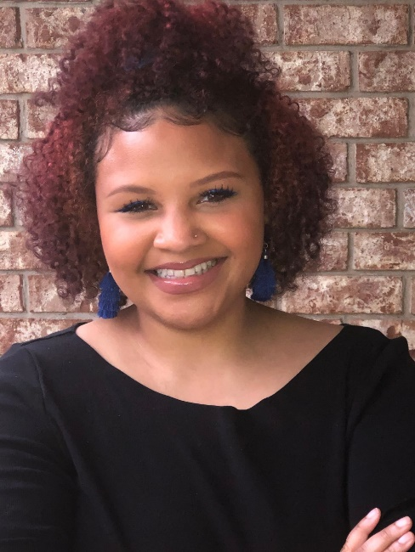 |  |  | WELCOME TO MIDDLE SCHOOL ART CLASS!  I am so excited to have you in class this semester! Not only will we be creating beautiful works of art, but we will be building a solid foundation so that you will be able to use your creativity and art skills in each of your other classes.  Art is about building a relationship between who you are as a student/individual and who you are becoming as an artist.  Education  Liberty University 2020- current (Specialist in Curriculum and Instruction)  Grand Canyon University- Masters in Secondary Education  University of South Carolina- Bachelor of Arts in Art Studio  Davidson Fine Arts Magnet School  Get to Know Me  Favorite Food: Pizza with honey  Favorite Drink: Starbucks  Music: Country music  Hobbies: Spending time with Cameron, shopping, watching The Food Network,

Ms. Moorman

Visual Art Teacher
 | Phone:  (706) 821- 2766
 | Email:  MoormMa1@boe.richmond.k12.ga.us
 | Website:  https://www.rcboe.org/belair
 | Address  3925 Harper Franklin Avenue  Augusta, Georgia 30909
 | Art Skills  Drawing, painting, watercolor, collages, charcoal, paper mâché

